**Ocean Modelling (AS308)**

**Assignment 1**

**Mixed layer dynamics using PWP model**

Name : Parag Shende

SR No. : 23895

**Model Configuration**

* We study the mixed layer dynamics using the 1D PWP model.
* The model simulates the dynamics of mixed layer subject to various surface fluxes (wind stress, freshwater, latent heat and sensible fluxes) and the penetrative shortwave flux.
* The model solves the following set of equations that are discretized on an uniform vertical grid (signifying a single station).
* The model basically simulates how the mixed layer reacts to shear instabilities.
* There are three different criteria on which the mixed layer is defined:
  + Static stability
  + Bulk stability
  + Gradient stability
* For our study, we have two different stations in the interior of Bay of Bengal(15N,85E) and Arabian Sea(15N,70E).
* We simulated the mixed layer for a period of 1 year, starting from 1st January 2013 to 31st December 2013.
* The initial conditions were obtained from Copernicus Marine Stores GLORYS 1/12-degree reanalysis output for 1st January 2013.
* The forcings the model requires are:
  + Shortwave flux on the surface
  + Longwave flux on surface
  + Precipitation
  + Latent heat on the surface
  + Sensible heat on the surface
  + The wind stress on the surface in zonal and meridional directions.
* All of the above forcings were obtained from ERA5 Reanalysis and input to model at 3 hourly frequencies.
* We perform three experiments on both the stations:
  + Experiment 1: Freshwater sensitivity
    - Run 1: All forcings are ON
    - Run 2: Freshwater forcing is OFF
  + Experiment 2: Vertical mixing schemes sensitivity
    - Run 1: No vertical mixing/Convective instability
    - Run 2: Gradient mixing ONLY
    - Run 3: Bulk mixing ONLY
    - Run 4: All mixing schemes ON
  + Experiment 3: High frequency forcings run
    - Run 1: no vertical mixing/Convective instability: HF
    - Run 2: Gradient mixing ONLY: HF
    - Run 3: Bulk mixing ONLY: HF
    - Run 4: All mixing schemes ON: HF
* The model is discretized at an uniform grid (of dz = 0.5m) and the maximum depth being 250m.
* The model output was at a 3 hourly frequency.

**Experiment 1: Freshwater forcing sensitivity**

* The first experiment consists of studying the mixed layer dynamics under freshwater sensitivity.
* The different runs are:
  + Run 1: All forcings are ON
  + Run 2: Freshwater forcing(E-P) is OFF

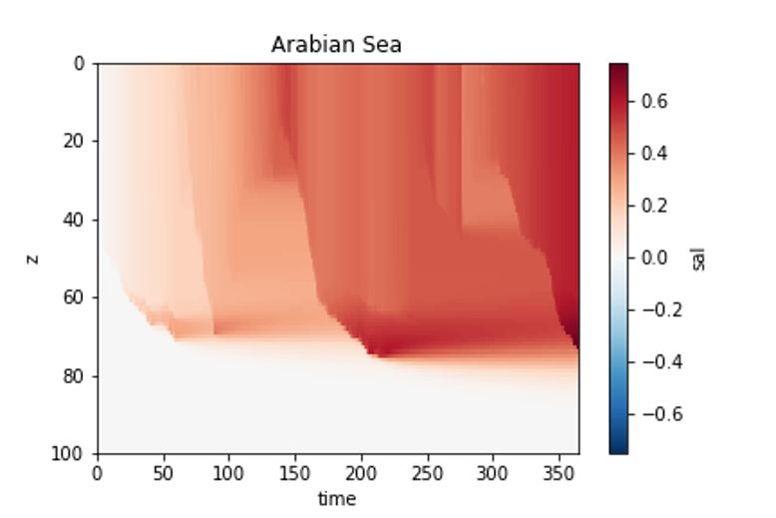

**Figure 1: Salinity Bias in Arabian Sea**

* We find that the salinity bias (Run1 – Run2) in the Arabian Sea is consistently positive. This means that the basin is predominantly evaporative and hence switching OFF freshwater forcing lowers the salinity in the perturbation run.

**Figure 2: Salinity Bias in Bay of Bengal**

* The Bay of Bengal on the other hand shows a bifurcation in the bias (Run1 – Run2) in salinity, with January to June showing a positive bias and July to December showing a negative bias. This is due to the fact that during monsoon and post monsoon the Bay of Bengal receives a large freshwater flux, hence switching OFF freshwater will cause the perturbation run to be more saline than control run.

**Experiment 2: Vertical mixing schemes sensitivity**

* This experiment consists of the gauging the sensitivity of model to various mixing schemes present in the model which are based on three criteria:
  + Static stability
  + Gradient mixing
  + Bulk mixing
* The runs in the experiment are as follows:
  + Run 1: No vertical mixing/Convective instability
  + Run 2: Gradient mixing ONLY
  + Run 3: Bulk mixing ONLY
  + Run 4: All mixing schemes ON

**Figure 3: Arabian Sea on 26th July**

* The Arabian Sea response to steady wind and a diurnal shortwave is shown for 26th July. We notice that the mixed layer has deepened to about 80m consistent with the observation for that area during that time.
* The No mixing run produces the shallowest mixed layer depth owing to absence of shear schemes.
* Next, we look at the case of 9th August, when the winds were somewhat low in magnitude and were steady. We see that the mixed layer is shallower than the previous case owing to insufficient shear mixing by the low magnitude winds.
* A graph of different types of wind stress

  Description automatically generated

**Figure 4 : Arabian Sea on 9th August**

* The mixed layer becomes surface trapped during the day owing to high solar insolation and winds being weak. The mixed layer during this whole diurnal cycle never deepens as much as on the 26th of July.

**Figure 5: Arabian Sea on 9th November**

* Finally, we have the case for 22nd November where an absence of wind stress and a strong solar insolation cause the mixed layer to shoal. The mixed layer deepening can be attributed to convective instability instead of shear instability.
* The surface trapped diurnal jet is clearly visible in all the four runs, with the deepest mixed layer depth being simulated by the presence of all mixing schemes.

**Figure 6: Bay of Bengal on 26th September**

* We see that on 26th September, when the wind forcing is steady, the mixed layer depth is quite shallow, around 40m at max., consistent with the observation.

**Figure 7: Comparison of mixed layer depth for Arabian Sea (AS) and Bay of Bengal (BoB)**

* The comparison of mixed layer depth for the two basins shows mixed layer is deeper in the Bay of Bengal during January to April and shallows afterward.

**Experiment 3: High frequency forcings sensitivity**

* The next experiment consists of comparing the mixed layer response to high frequency forcings (all mixing schemes are ON).
* The forcings are bandpass filtered. The forcings are bandpass on a time period of 1 day to 60 day and then added to the root mean square of the forcing. This is done for wind stresses, shortwave, longwave.
* The magnitude of the high frequency wind stresses(yellow arrows) is more than the normal forcings(purple arrows). This will imply that the high frequency forcing runs will always have a deeper mixed layer, which is indeed the case in all the runs.
* Also, going from free convection run to full mixing schemes run there is a consistent deepening of the mixed layer depth.

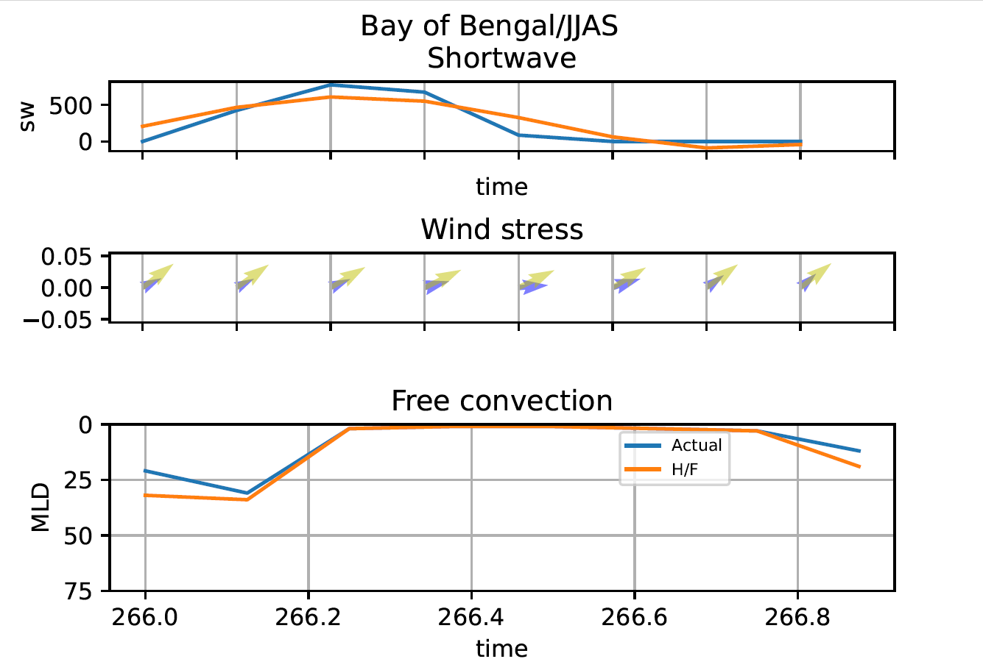

**Figure 8: Free Convection case for Bay of Bengal for JJAS**

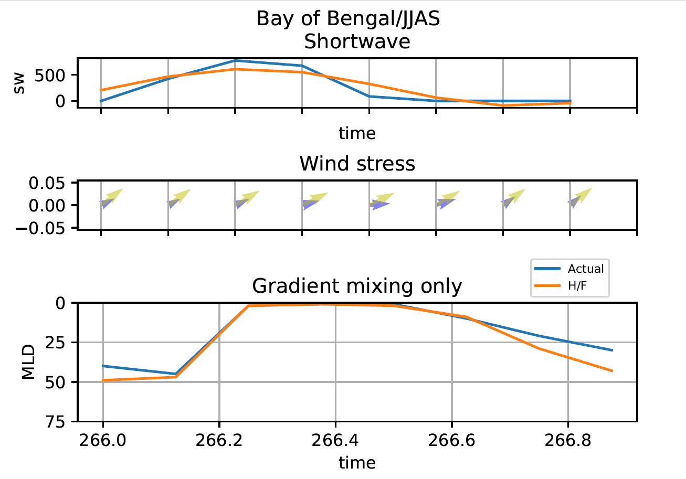

**Figure 9: Gradient mixing only run for Bay of Bengal in JJAS**

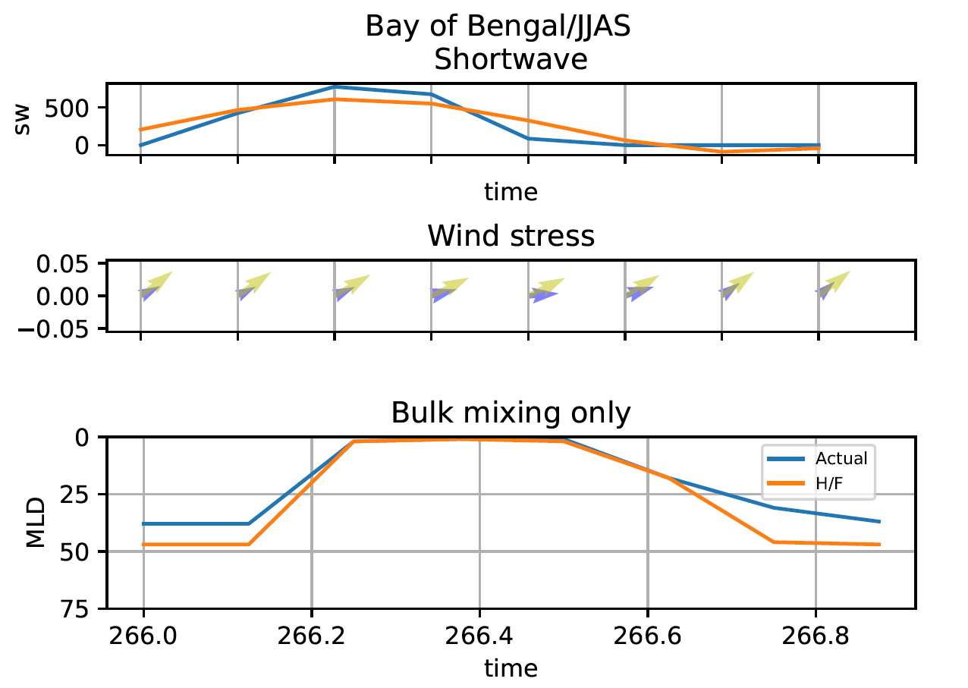

**Figure 10: Bulk mixing scheme for Bay of Bengal in JJAS**

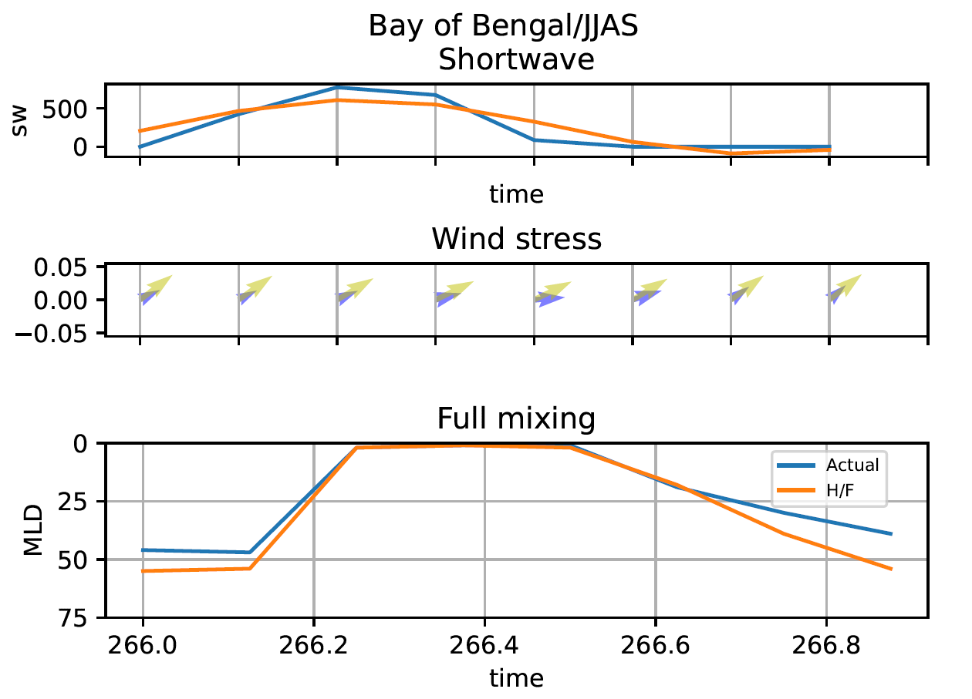

**Figure 11: Full mixing scheme for Bay of Bengal for JJAS**

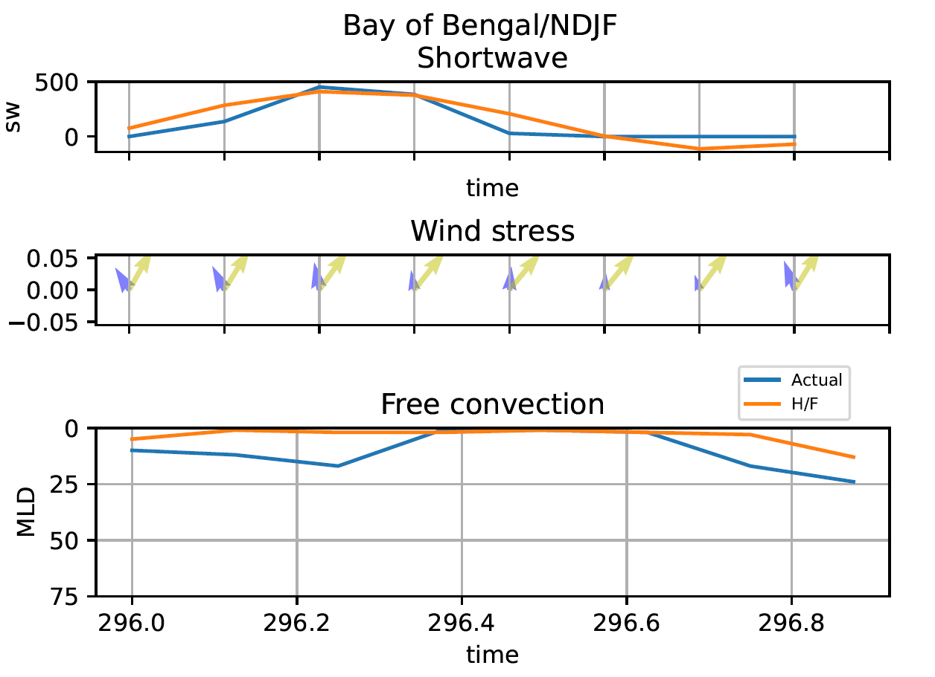

**Figure 12: Free convection run for Bay of Bengal in DJF**

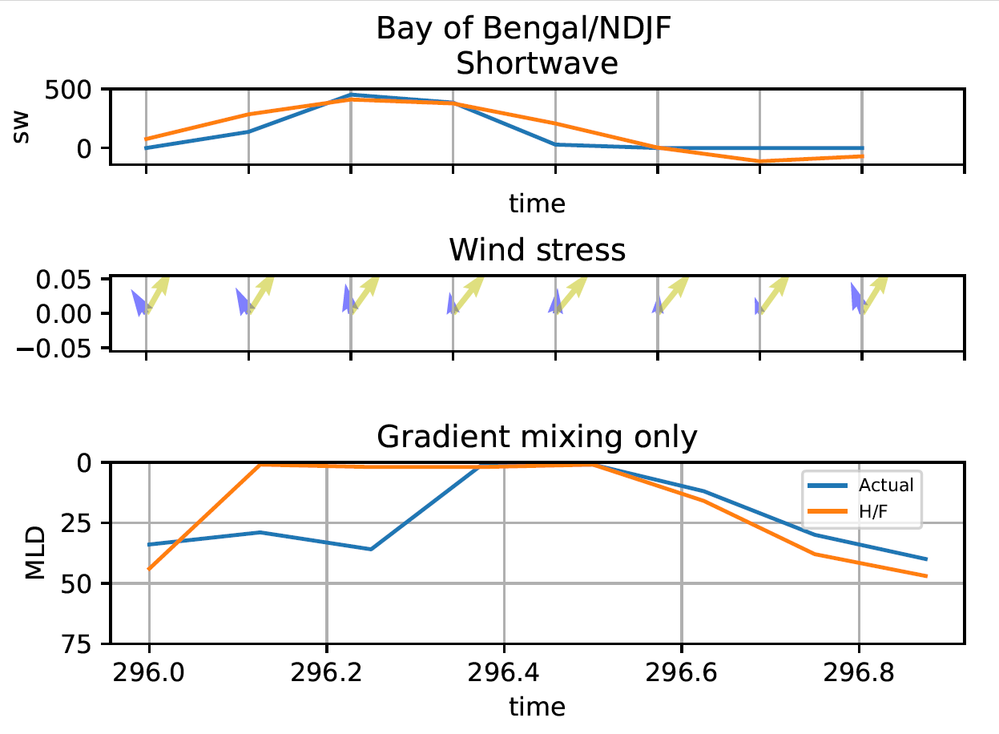

**Figure 13: Gradient mixing case for Bay of Bengal in DJF**

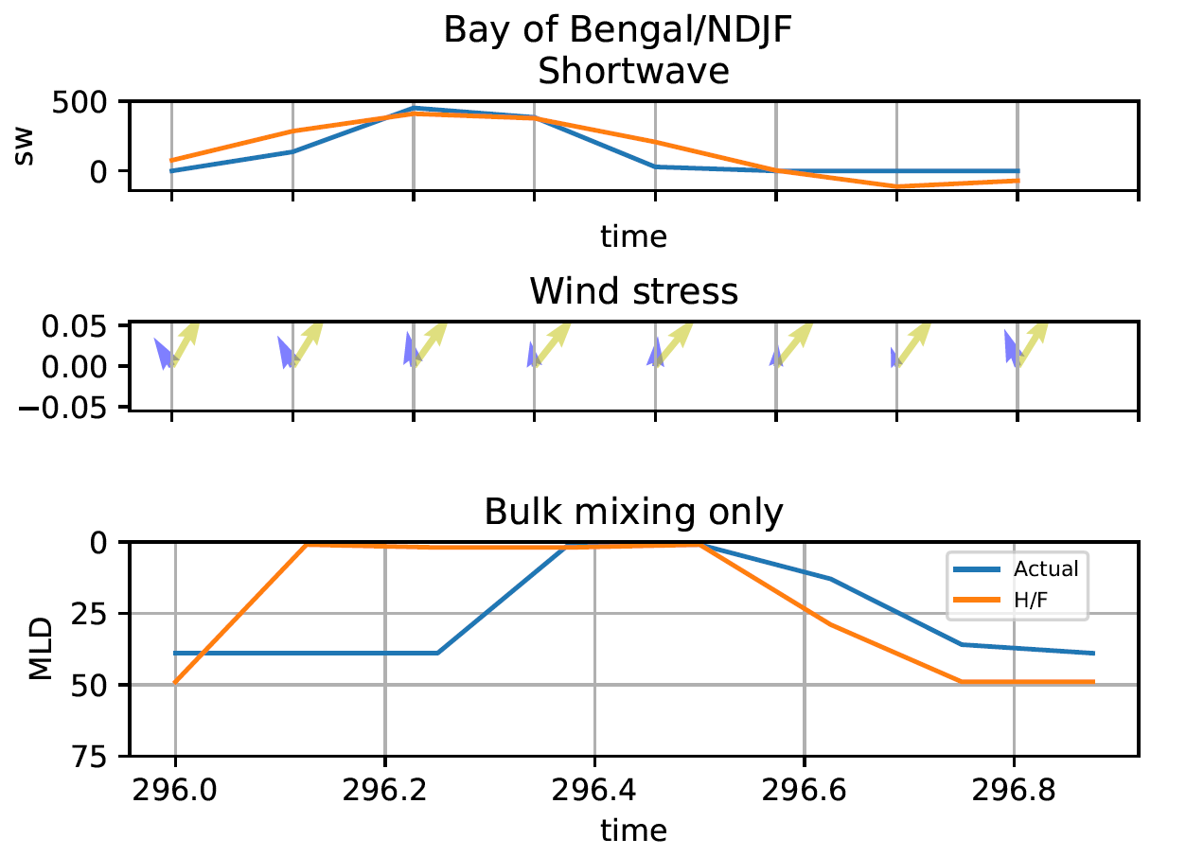

**Figure 14: Bulk mixing case of Bay of Bengal in DJF**

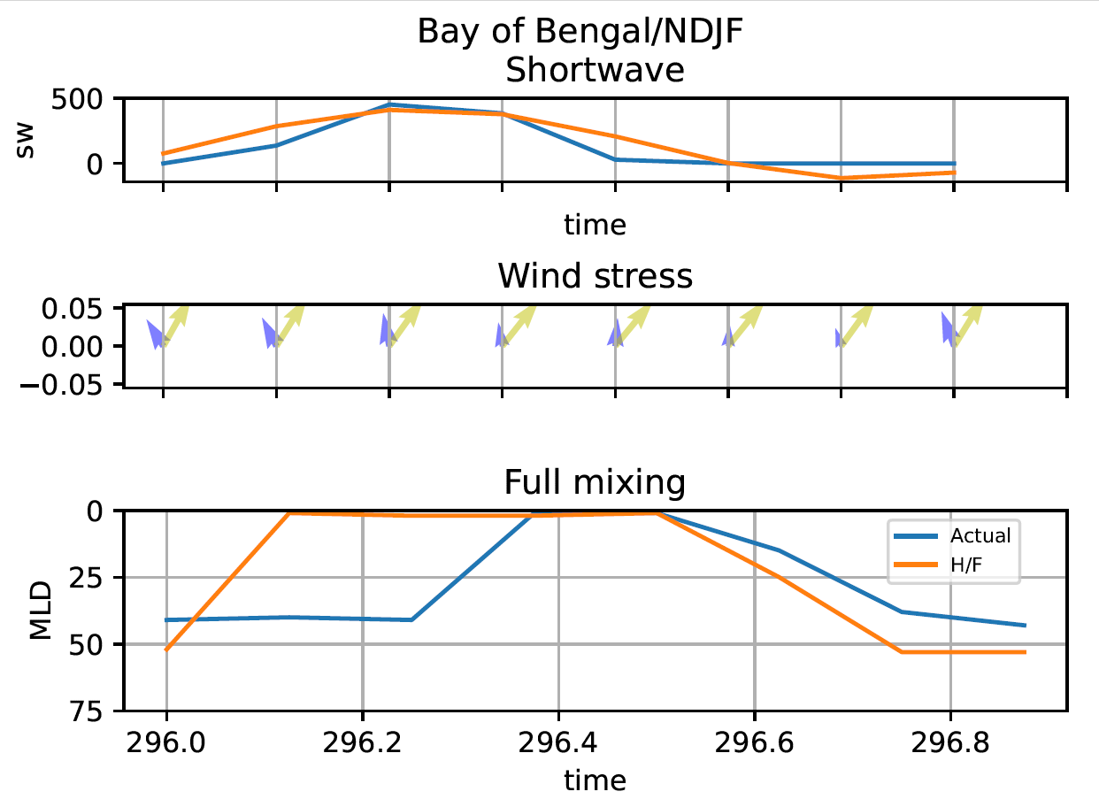

**Figure 15: Full mixing schemes for Bay of Bengal in DJF**